**BIGTREETECH TFT3.5 V2.0**

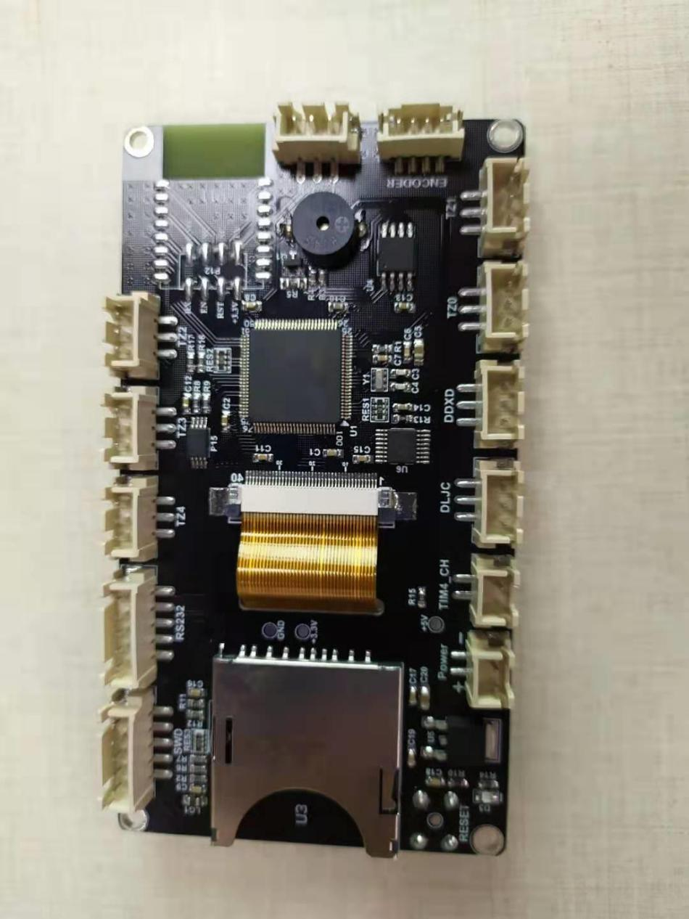**User manual**

# Product Introduction

BIGTREETECH TFT35-V3.0 is a medium size and ultra-clear 3D printing machine display launched by the 3D printing team of Shenzhen BIGTREE technology co., LTD.

1. **Product characters**

1、ARM Cortex-M3 series STM32F103VCT6 chip with 32 - bit CPU 72MHz;

2、Equipped with modular open source firmware, it is convenient for users to DIY and secondary development

3、Integrate Keil MDK5 development environment with mainstream development tools; Support online debugging, more helpful for product development and performance optimization, C language development, low development threshold;

4、PCB wiring is precise and beautiful

5、Using special power chip, 5V dc power input

6、Equipped with 3.5 inch color touch screen, with rich colors, support 65536 colors

7、The system supports simplified Chinese, English and other languages, can be switched;

8、Update and configure firmware with SD card, easy to operate;

9、Support serial wifi

10、Support the functions of power off, continuous play, material failure detection, shutdown, etc.;

11、Visual human-computer interaction interface.

12. When the display is powered up, the indicator D3 will light up, indicating that the power supply is normal.

1. Product Parameters

1) Appearance size：110*60mm

2) Installation size：105*55mm

* 1. Microprocessor：ARM Cortex-M3 CPU
  2. Power Input：DC5V
  3. External flash storage
  4. External EEPROM
  5. Passive buzzer alarm
  6. Touch the chip
  7. 3.5” TFT touchscreen
  8. External SD card slot
  9. Onboard serial WIFI port
  10. SWD debug port
  11. 7 extended I/O ports
  12. USART1 & USART3 port
  13. Encoder input port
  14. Reset button

# Ports on the board

Size diagram

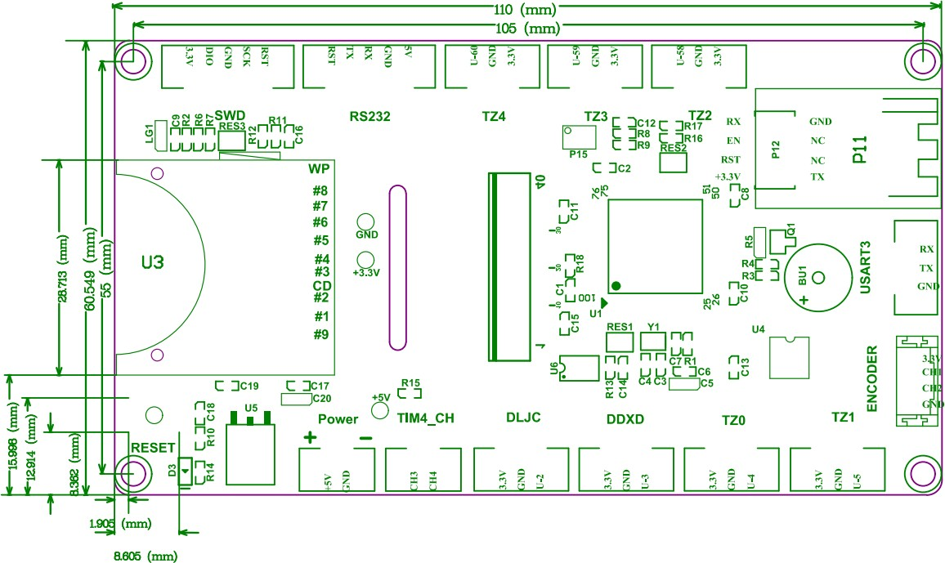

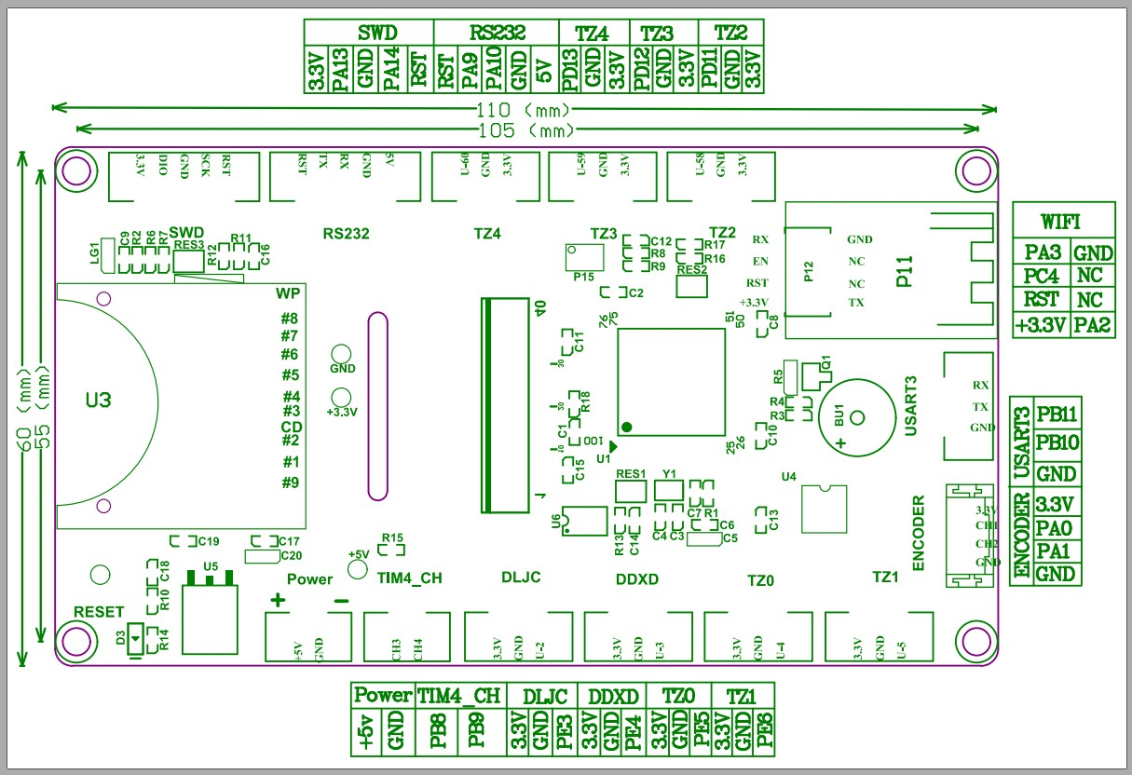

Connection diagram

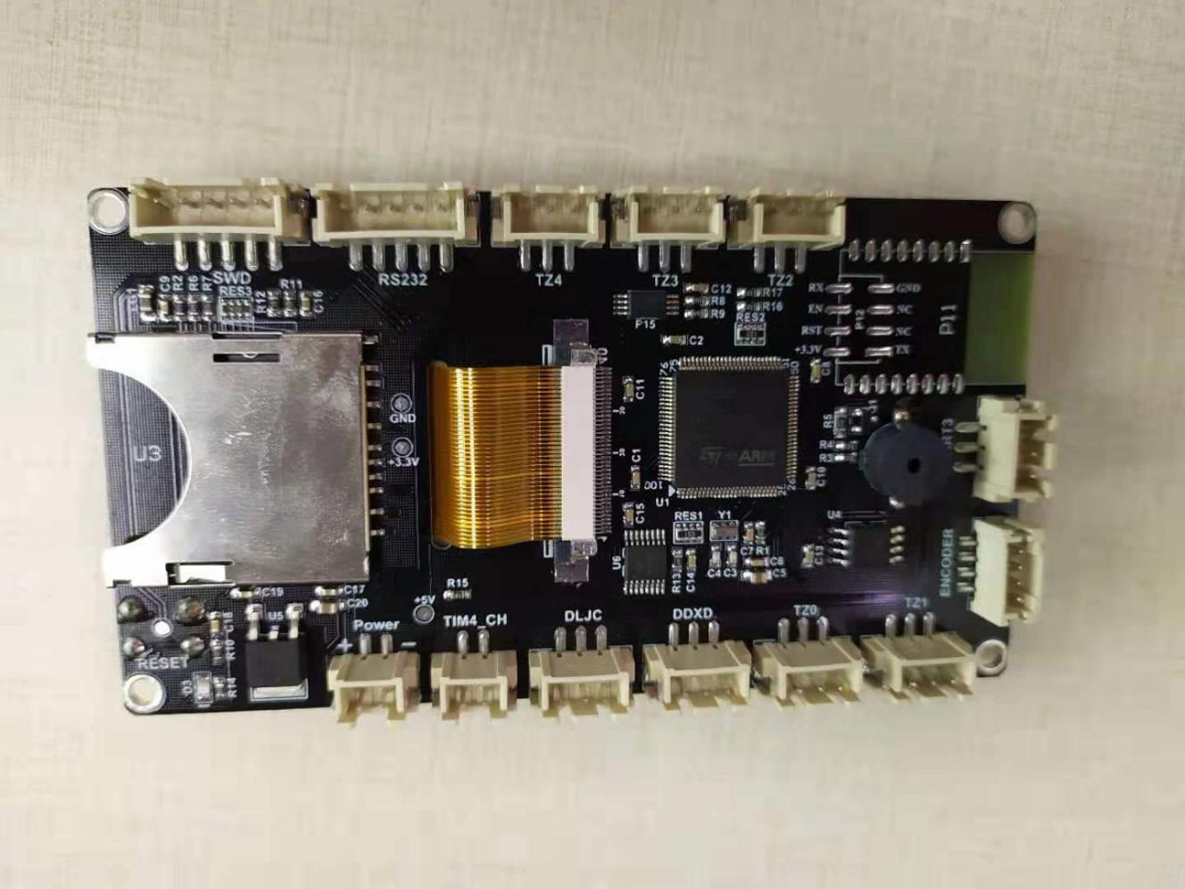

IO扩展口

Wifi扩展口

USART3

接口扩展

编码器输入接口

IO扩展口

USART1接口

SWD程序调试口

DC5V接口

断料接口

打完关机接口

|  |  |  |  |  |  |
| --- | --- | --- | --- | --- | --- |
|  |  |  |  |  |  |

**III. Firmware Introduction**

# Factory board will be equipped with test firmware, it can be used directly.

User can also change the firmware according to their own need.

1. Ways to obtain the firmware of motherboard

1)Get it from customer service or technical staff

2)Log in the open source website of our company to download: <https://github.com/bigtreetech>

**V. Notes**

1.The name of the firmware file in the SD card cannot be changed. (including capital and small letters)

2.Wiring process must be under the precondition of power outages. Users must check the correct connection of the circuit and the correct insertion of the drive module before turning on electricity. Pay attention to the wiring sequence and do not insert the wire inversely. Please refer to PIN file for detailed line order.

If you meet other problems in the use, you are welcome to contact us, we will answer for you carefully. If you have any good comments or suggestions on our products, you are welcome to give us feedback, and we will carefully consider your comments or suggestions. Thank you for supporting BIGTREETECH products.